

St John’s C.E. (Aided) School
Weekly Update
Please see the following notices and attachments for week commencing 22/06/2026.
DATES FOR YOUR DIARY

18/06/2026 – Year 6 Residential meeting at 6pm.

19/06/2026 – PTA ‘Break the Rules Day’ The children can choose to break as many of the school rules listed on the poster below as they wish. Each rule broken will cost 50p.
A sum-up link for donations will be sent via class reps or cash will be accepted on the day.

19/06/2026 – Woodwind assembly.

22/06/2026 - Year 2 Hever Castle trip.

23/06/2026 – Year 3 Wakehurst Place trip.
25/06/2026 - We will be holding a parent information evening on Thursday 25th June. The evening will focus on the revised Personal, Social and Health Education (PSHE) and Relationships Curriculum for September 2026. It will start at 7pm promptly and should last approximately 1 hour. If you are interested in coming, please email the office to confirm your attendance. This event has now been cancelled due to apparent lack of interest – Mrs Cooper will put together some information that will be put on the school website by the end of term.
26/06/2026 – PTA own clothes day in exchange for donations for the Summer Fair. R, 1, 2 and 3 individually packaged sweets and 4, 5 and 6 bottles (alcohol, soft drinks, smellies etc)
GENERAL INFORMATION AND ATTACHMENTS
- Thank you to all of you that attended our Sports Day, what a fabulous day we all had!! Just as a reminder in case you weren’t aware from the cheers, that St Anthony came in first place.

- Summer Fair news:
Please see the attached flyer for the key Summer Fair dates.
We're almost done with the preparation for the Summer Fair, but we still need some volunteers to help set up and man some stalls on the day.
Please sign up here. If you are able to bake something for our tea and cake stall, please let us know here.
We can't wait to welcome you to this year's Summer Fair on Saturday 4th July, 2-5pm.
- We have sadly made the decision to retire the fish tank from outside the school office. The tank and all its interior (gravel, plants and equipment to clean) are available for a donation to anyone who would be interested in becoming a fish owner! Or if you would like to repurpose it for another use.

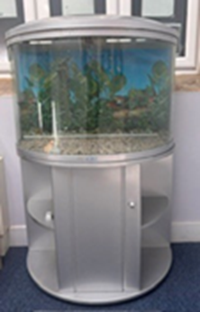

- Please see attached flyers for various different events.

